Name: Sharma Raj Bablu

Roll.no: 41
Division: SE-3 / S3
Branch: C.S.E(D. S)
Subject: M.D.M

EXPERIMENT NO.08
Aim: - Building a Simple Counter App using React Hooks. Use React Hooks (useState, useEffect) to manage state and side effects.

Code: -
import React, { useState, useEffect } from "react";

// Simple Counter App using React Hooks export default function CounterApp()
{ const [count, setCount] = useState(0);

// Side effect: update document title whenever count changes useEffect(() => { document.title = `Count:
${count}`;
},
[count]); const increment = () => setCount(count + 1); const decrement = () => setCount(count - 1); const reset = () => setCount(0); return (
<div style={{ textAlign: "center", marginTop: "50px" }}>
<h1>React Counter App</h1>
<h2>{count}</h2>
<button onClick={increment}>➕ Increment</button>
<button onClick={decrement} style={{ margin: "0 10px" }}>
➖ Decrement
</button>
<button onClick={reset}>🔄 Reset</button>
</div>
);
}

Output: -
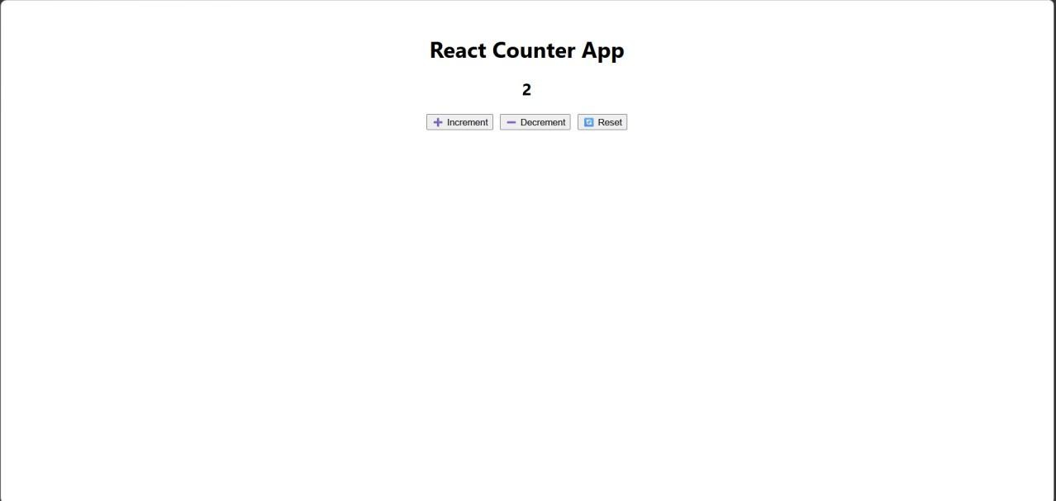

Conclusion: -
Thus, a simple counter application was successfully developed using React Hooks. The experiment demonstrates the use of useState for state management and useEffect for handling side effects. This approach simplifies component logic and improves code readability in modern React applications.

Questions: -
- What are React Hooks?
React Hooks are special functions that allow you to use state and lifecycle features in functional components (without writing class components).
Common Hooks:
  - useState → Manages state
  - useEffect → Handles side effects (API calls, DOM updates)
  - useContext → Access global data
Example: const [count, setCount] = useState (0);
This creates a state variable count and a function setCount to update it.

- How does React re-render components?
React re-renders a component when its state or props change.
Process:
  - State/props change (e.g., setCount() is called)
  - React creates a Virtual DOM
  - Compares it with the previous Virtual DOM (diffing)
  - Updates only the changed parts in the real DOM
This makes React fast and efficient.

- How does React re-render components?
React re-renders components when there is a change in state or props. It uses the Virtual DOM to compare changes and updates only the necessary parts of the real DOM for better performance.

